# loc and iloc

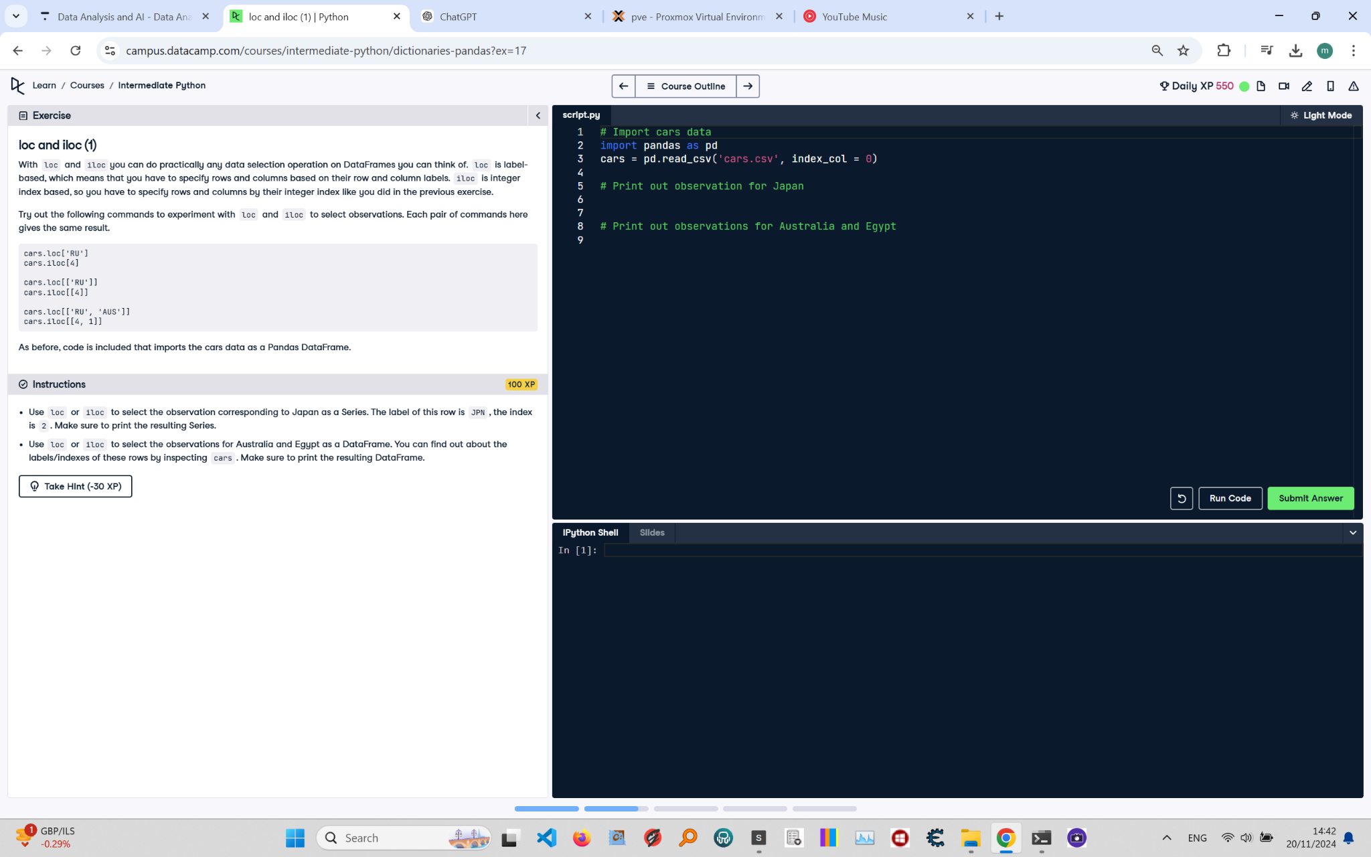

## Question:

Use loc or iloc to select the observation corresponding to Japan as a Series. The label of this row is JPN, the index is 2.  
 Make sure to print the resulting Series.  
  
 Use loc or iloc to select the observations for Australia and Egypt as a DataFrame. You can find out about the labels/Indexes  
 of these rows by inspecting cars. Make sure to print the resulting DataFrame.

## Answer:

# Import cars data  
 import pandas as pd  
 cars = pd.read_csv('cars.csv', index_col=0)  
   
 # Print out observation for Japan  
 print(cars.loc['JPN'])  
   
 # Print out observations for Australia and Egypt  
 print(cars.loc[['AUS', 'EG']])

## Code Explanation:

1. `import pandas as pd`: Imports the pandas library, which is essential for data manipulation and analysis.  
 2. `cars = pd.read_csv('cars.csv', index_col=0)`: Reads the 'cars.csv' file into a pandas DataFrame and sets the first column as the index.  
 3. `print(cars.loc['JPN'])`: Uses the `loc` method to access the row labeled 'JPN' in the DataFrame, which corresponds to Japan, and prints it as a Series.  
 4. `print(cars.loc[['AUS', 'EG']])`: Uses the `loc` method to access rows labeled 'AUS' (Australia) and 'EG' (Egypt) as a DataFrame and prints them.